DECIMAL TO HEXA

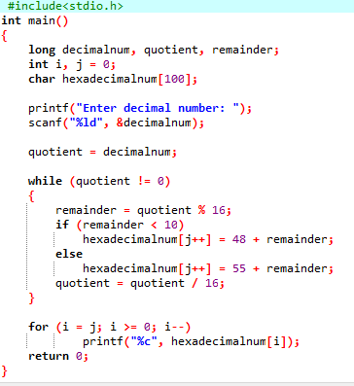

OUTPUT

